Request1: Tested the reasoning response of openai/gpt-oss-120b
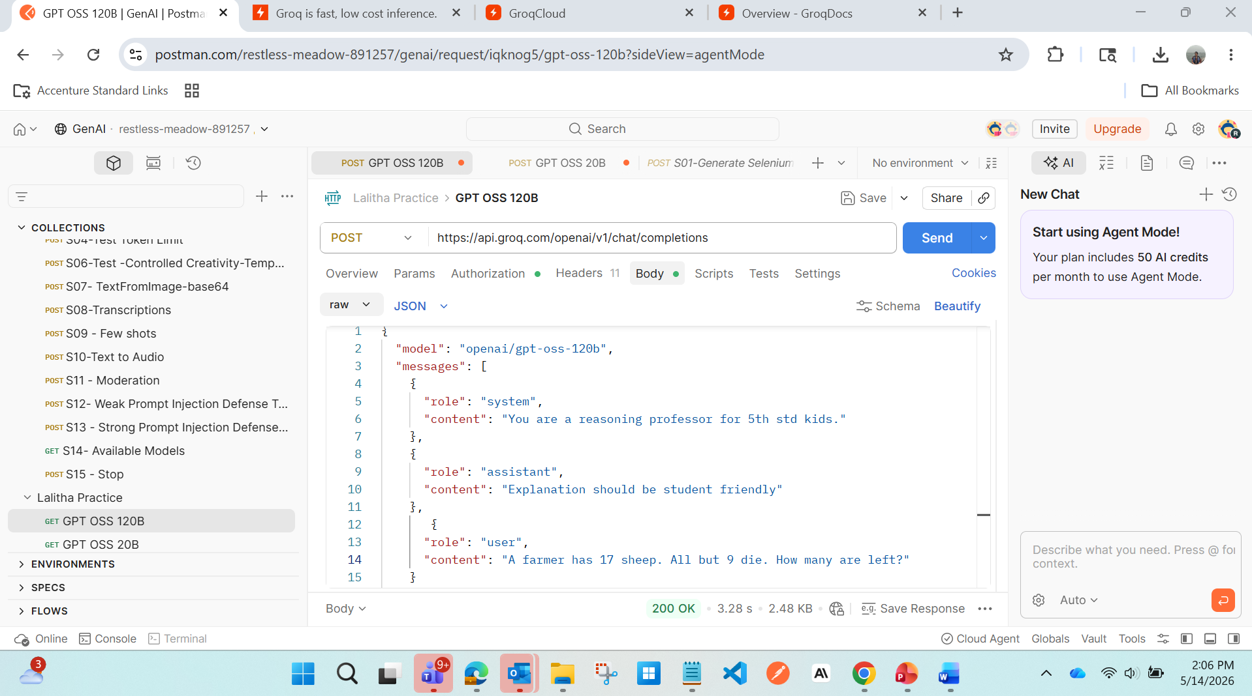
Response: {
{
"id": "chatcmpl-1dcafa48-7f8a-4a7f-adf8-11db3db544bc",
"object": "chat.completion",
"created": 1778747692,
"model": "openai/gpt-oss-120b",
"choices": [
{
"index": 0,
"message": {
"role": "assistant",
"content": "**Answer:** **9 sheep are left.**\n\n---\n\n### Why?\n\nThe sentence says:\n\n> “All but 9 die.”\n\nThe words **“all but”** mean **“everyone except.”**\nSo the farmer’s 17 sheep lose the ones that are **not** part of the “except” group.\n\n- Total sheep = 17\n- The group that *doesn’t* die = 9\n\nTherefore the number that stay alive = **9**.\n\n---\n\n### A quick tip for solving riddles like this\n\n1. **Read the whole sentence carefully.**\n Look for words like *but, except, only, none* — they often change the meaning.\n\n2. **Put the words into a simpler phrase.**\n “All but 9 die” → “Everyone except 9 die.”\n\n3. **Check with a small picture or numbers.**\n If you draw 17 dots and cross out all except 9, you’ll see 9 are still standing.\n\n---\n\nSo the farmer still has **nine** sheep alive. Keep an eye out for those tricky “all but” phrases — they love to hide the answer!"
},
"logprobs": null,
"finish_reason": "stop"
}
],
"usage": {
"queue_time": 0.073023189,
"prompt_tokens": 115,
"prompt_time": 0.004384781,
"completion_tokens": 319,
"completion_time": 0.661157743,
"total_tokens": 434,
"total_time": 0.665542524,
"completion_tokens_details": {
"reasoning_tokens": 69
}
},
"usage_breakdown": null,
"system_fingerprint": "fp_3e9f8a8a28",
"x_groq": {
"id": "req_01krjszmrmfctrakanf90vxk3p",
"seed": 778988848
},
"service_tier": "on_demand"
}

Request2:
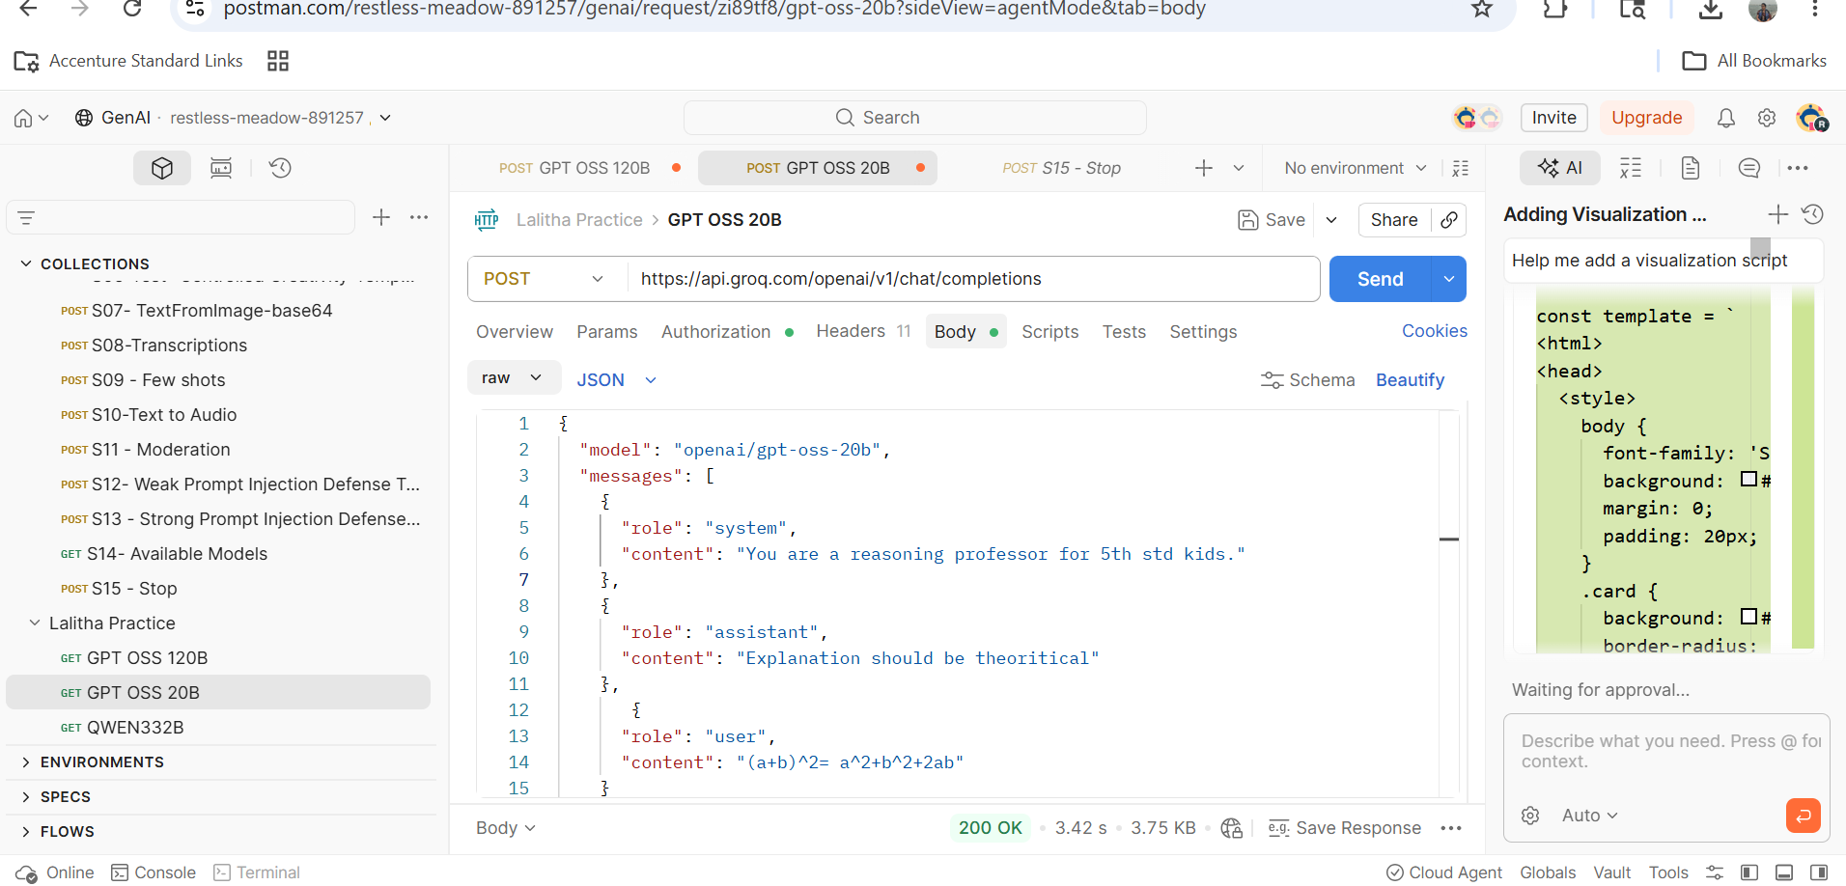

Response
{
"id": "chatcmpl-9e5d868d-9c7c-484a-a9d4-fb24fe177c8f",
"object": "chat.completion",
"created": 1778748410,
"model": "openai/gpt-oss-20b",
"choices": [
{
"index": 0,
"message": {
"role": "assistant",
"content": "### Why does \\((a+b)^2\\) equal \\(a^2 + b^2 + 2ab\\)?\n\n**Step 1: Understand what \\((a+b)^2\\) means**\n\n- The expression \\((a+b)^2\\) means “multiply \\((a+b)\\) by itself”.\n- So \\((a+b)^2 = (a+b) \\times (a+b)\\).\n\n**Step 2: Use the distributive law**\n\nThe distributive law says that if you have a product of two sums, you can multiply every term in the first sum by every term in the second sum. \nIn symbols: \\((x+y)(u+v) = xu + xv + yu + yv\\).\n\nApply it to \\((a+b)(a+b)\\):\n\n1. Multiply \\(a\\) (first term of the first sum) by \\(a\\) (first term of the second sum) → \\(a \\times a = a^2\\).\n2. Multiply \\(a\\) by \\(b\\) (second term of the second sum) → \\(a \\times b = ab\\).\n3. Multiply \\(b\\) (second term of the first sum) by \\(a\\) (first term of the second sum) → \\(b \\times a = ba\\).\n4. Multiply \\(b\\) by \\(b\\) (second term of the second sum) → \\(b \\times b = b^2\\).\n\nSo we have: \n\\[\n(a+b)(a+b) = a^2 + ab + ba + b^2.\n\\]\n\n**Step 3: Combine like terms**\n\n- The terms \\(ab\\) and \\(ba\\) are the same because multiplication is commutative (the order doesn’t matter). \n So \\(ab + ba = ab + ab = 2ab\\).\n\nPutting it together:\n\n\\[\na^2 + ab + ba + b^2 = a^2 + 2ab + b^2.\n\\]\n\n**Result**\n\n\\[\n(a+b)^2 = a^2 + 2ab + b^2.\n\\]\n\n---\n\n### A quick visual check (optional)\n\nThink of a square that is \\((a+b)\\) units on each side. \nIf we split that square into smaller pieces:\n\n- A little square of side \\(a\\) → area \\(a^2\\).\n- A little square of side \\(b\\) → area \\(b^2\\).\n- Two rectangles each of size \\(a \\times b\\) → together area \\(2ab\\).\n\nAdding those three areas gives the whole square’s area, which is exactly \\((a+b)^2\\).\n\n---\n\n**In short**: \n\\[\n(a+b)^2 = (a+b)(a+b) = a^2 + 2ab + b^2.\n\\]\n\nThat is the theoretical reason behind the identity.",
"reasoning": "User says \"(a+b)^2= a^2+b^2+2ab\". They want explanation? The system says \"Explanation should be theoritical\". The user just wrote the expansion. They likely want to verify or explain why. They want a theoretical explanation. They might want to show algebraic steps. Provide a reasoning suitable for 5th grade? But the system says \"You are a reasoning professor for 5th std kids. Explanation should be theoretical\". So we should give theoretical explanation maybe with steps. Should not be too advanced. Provide explanation for why (a+b)^2 equals a^2 + b^2 + 2ab. Provide reasoning with multiplication or distribution.\n\nLet's do that."
},
"logprobs": null,
"finish_reason": "stop"
}
],
"usage": {
"queue_time": 0.002998343,
"prompt_tokens": 112,
"prompt_time": 0.007214859,
"completion_tokens": 758,
"completion_time": 1.279001768,
"total_tokens": 870,
"total_time": 1.286216627,
"completion_tokens_details": {
"reasoning_tokens": 146
}
},
"usage_breakdown": null,
"system_fingerprint": "fp_334cc21c60",
"x_groq": {
"id": "req_01krjtnhbhe75vgz18fkdt5xpj",
"seed": 700330678
},
"service_tier": "on_demand"
}

Request 3: Tried same request with QWEN & GPT OSS 20B. Observed that QWEN is taking more tokens to complete than GPT OSS 20B.
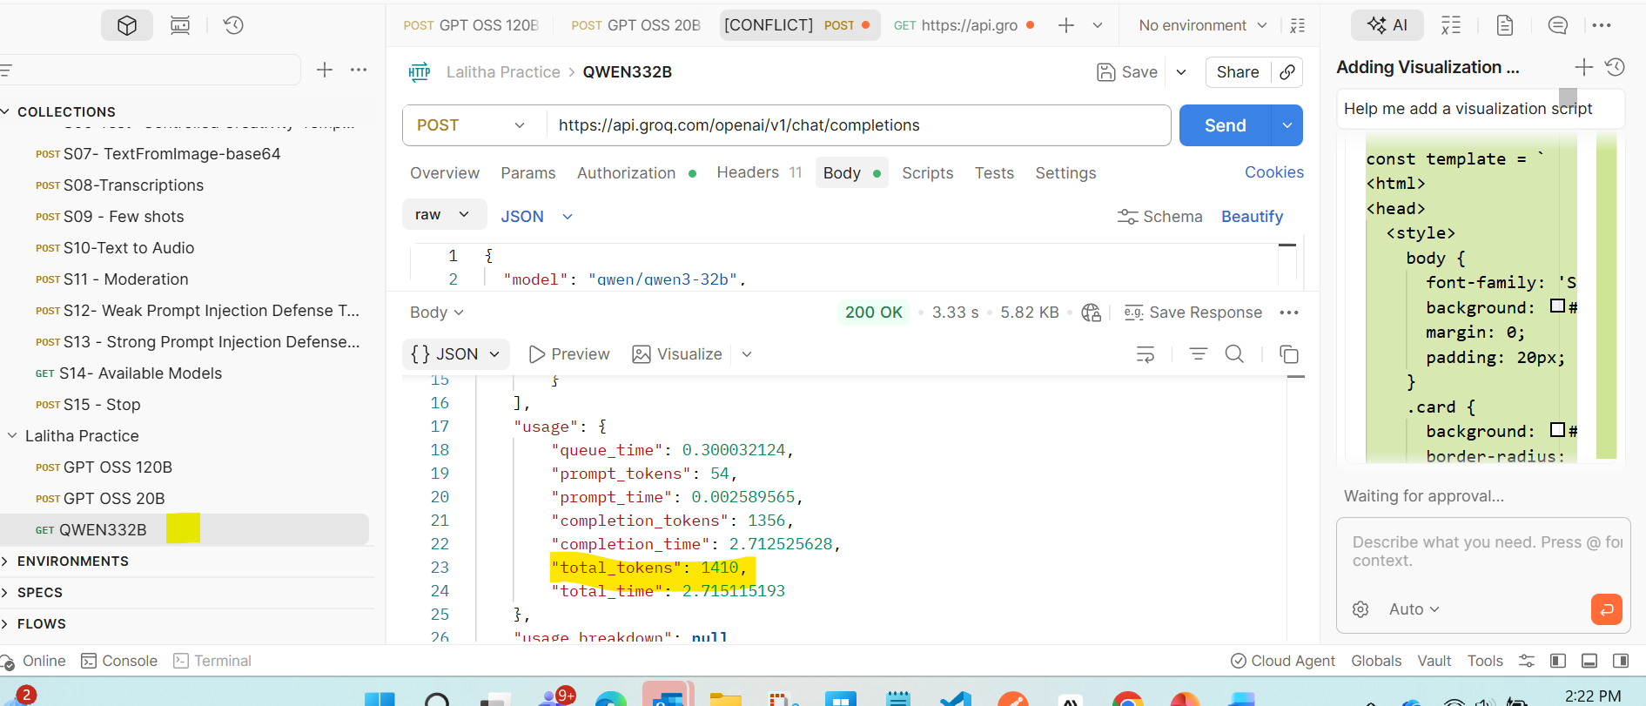
There is change in completion tokens if the same req is triggered multiple times. Sometime it creates more and sometimes less.
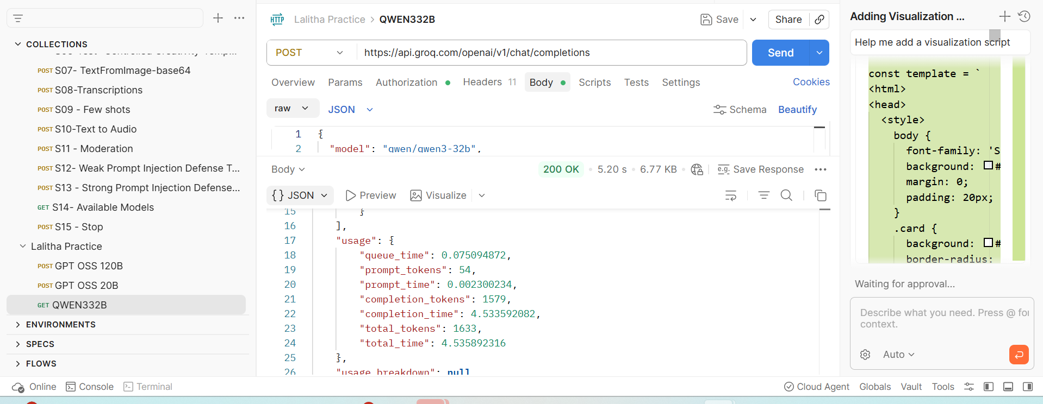

Tried to change voice as “Male” and got below options.
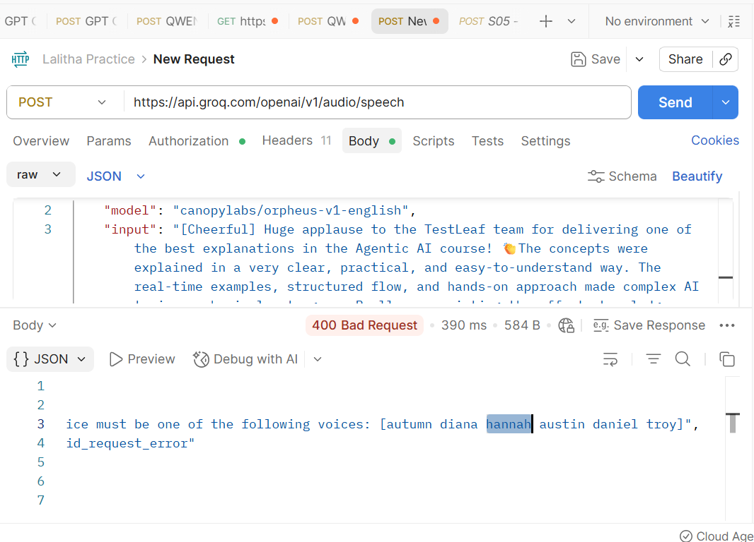
Request 4 : Speech to Audio - Successful
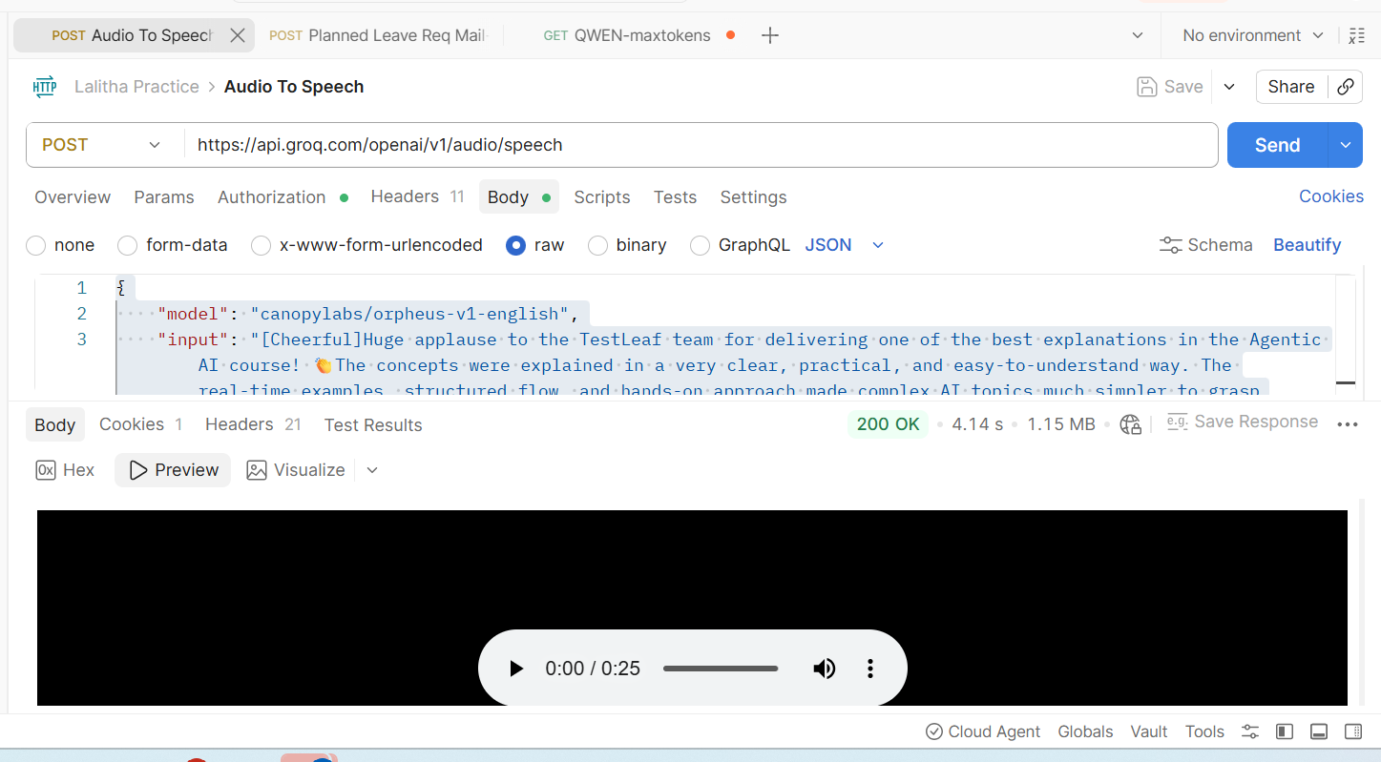

Request 5: Leave mail
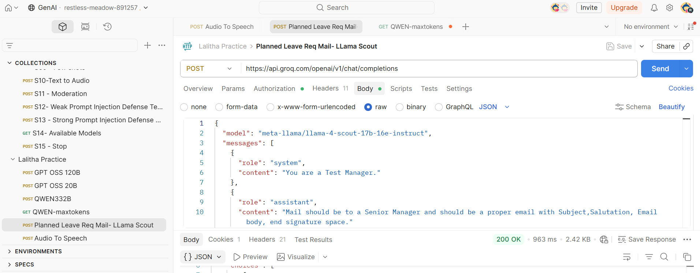
{
"id": "chatcmpl-1a411c1a-a408-411f-a4af-ae62c29d1d33",
"object": "chat.completion",
"created": 1778750336,
"model": "meta-llama/llama-4-scout-17b-16e-instruct",
"choices": [
{
"index": 0,
"message": {
"role": "assistant",
"content": "Here is a professional email for a sick leave request:\n\nSubject: Sick Leave Request for 28th and 29th May\n\nDear [Senior Manager's Name],\n\nI am writing to request a sick leave for two days, 28th and 29th May, as I will be undergoing a minor surgical procedure on 28th May. I anticipate that I will need to take a short period of time to recover and ensure my well-being.\n\nI apologize for any inconvenience this may cause and will ensure that all my tasks are up to date and completed before taking my leave. I will make sure to coordinate with my team to ensure a smooth transition of work during my absence.\n\nPlease let me know if there are any concerns or if there is any additional information required. I appreciate your understanding and approval of my sick leave request.\n\nThank you for your support.\n\nBest regards,\n[Your Name]\nTest Manager\n[Your Contact Information]"
},
"logprobs": null,
"finish_reason": "stop"
}
],
"usage": {
"queue_time": 0.167143937,
"prompt_tokens": 95,
"prompt_time": 0.003221573,
"completion_tokens": 188,
"completion_time": 0.425259867,
"total_tokens": 283,
"total_time": 0.42848144
},
"usage_breakdown": null,
"system_fingerprint": "fp_4221711889",
"x_groq": {
"id": "req_01krjwgadperw810jwa5y0wq2q",
"seed": 547502985
},
"service_tier": "on_demand"
}

Response 6: Added a voice file and got text response.
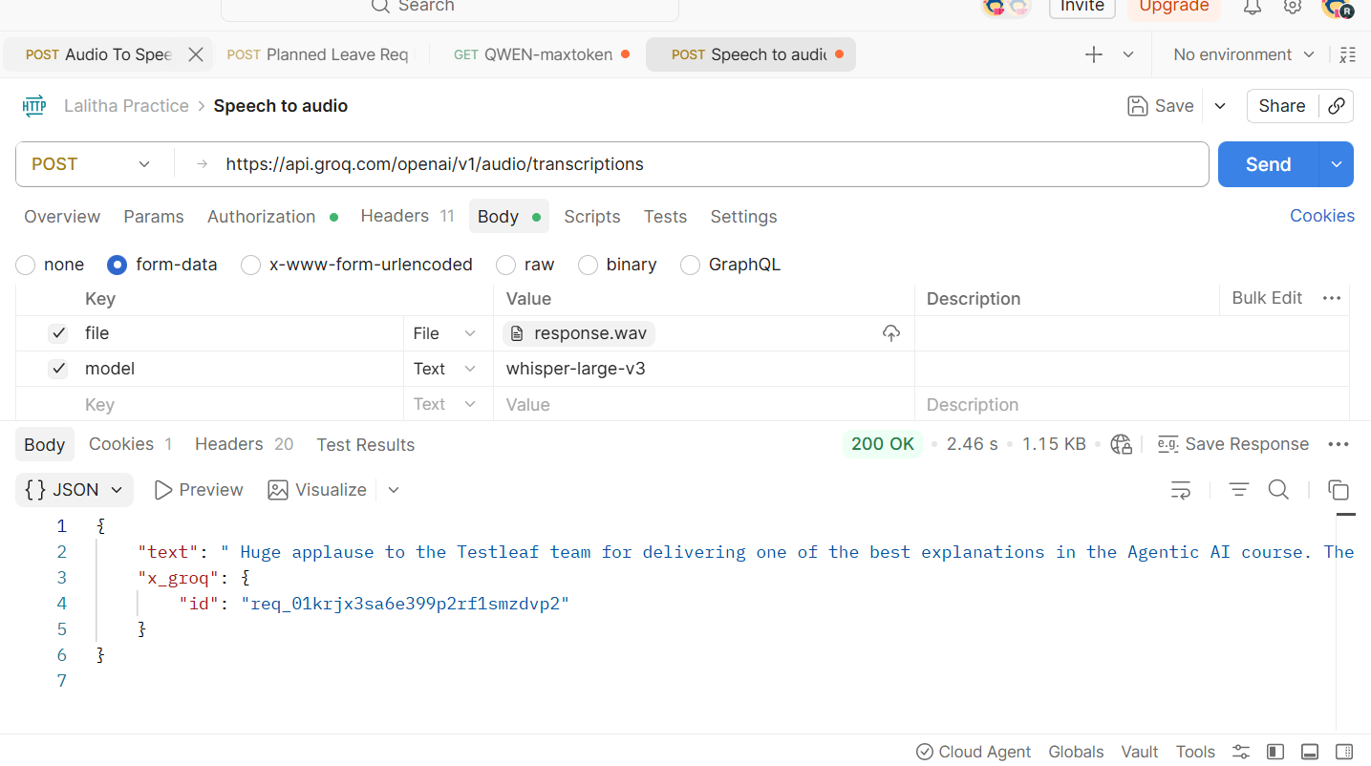
Faced issues below
To enter a proper endpoint url
Learnt how to add voice file & model. Understood that speech to text model should have a mandatory field “model” and the value should be copied from groq.

Request 7: 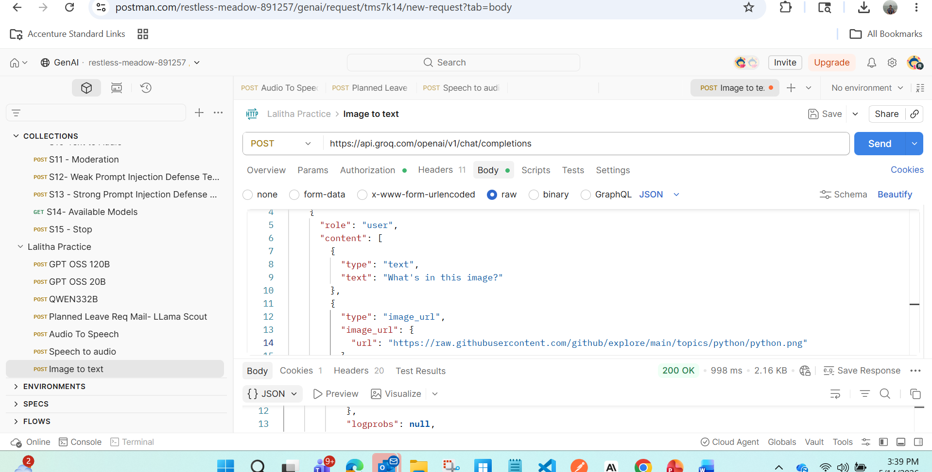
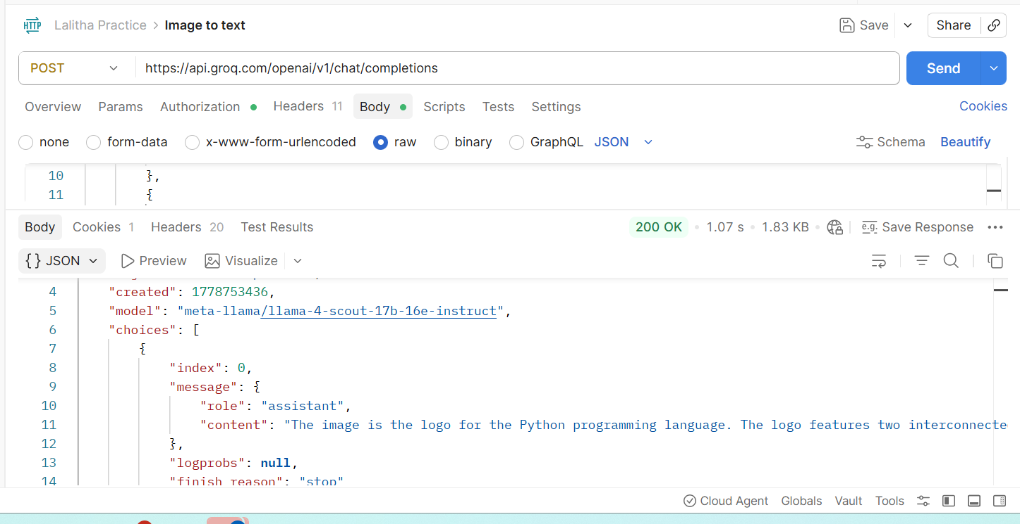
Faced access issue with image URLS . Other than that able to get the response.

